10 Linux Commands
1. Check whether Jenkins port 8080 is reachable
nc -zv localhost 8080
If Jenkins is listening on that port, the connection should succeed. The nc utility may need to be installed.
2. Find your system's DNS resolution
dig github.com
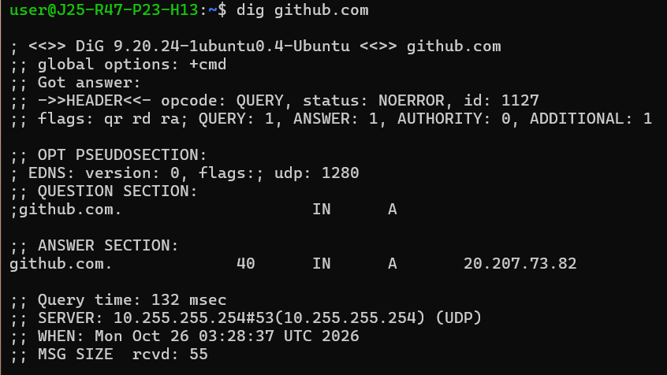
Useful when troubleshooting domain names and webhooks.
3. Check disk devices
lsblk -f
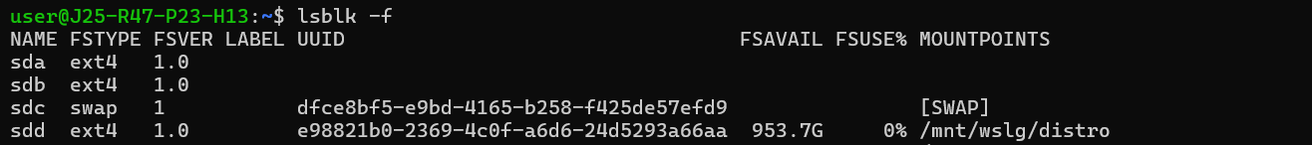
Shows disks, partitions, and detected filesystems.
4. Check scheduled jobs
crontab -l
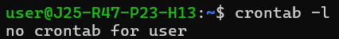
Displays your current user's scheduled jobs. It may report that no crontab exists.
5. Check CPU and memory activity
vmstat 2 5
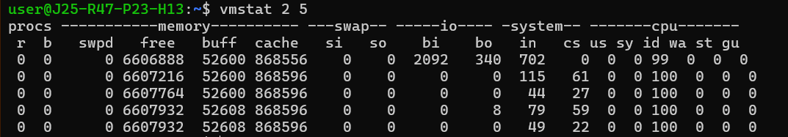
Displays CPU, memory, swap, and system activity every 2 seconds for 5 reports. Useful for identifying server performance issues.
6. Check CPU information
Lscpu
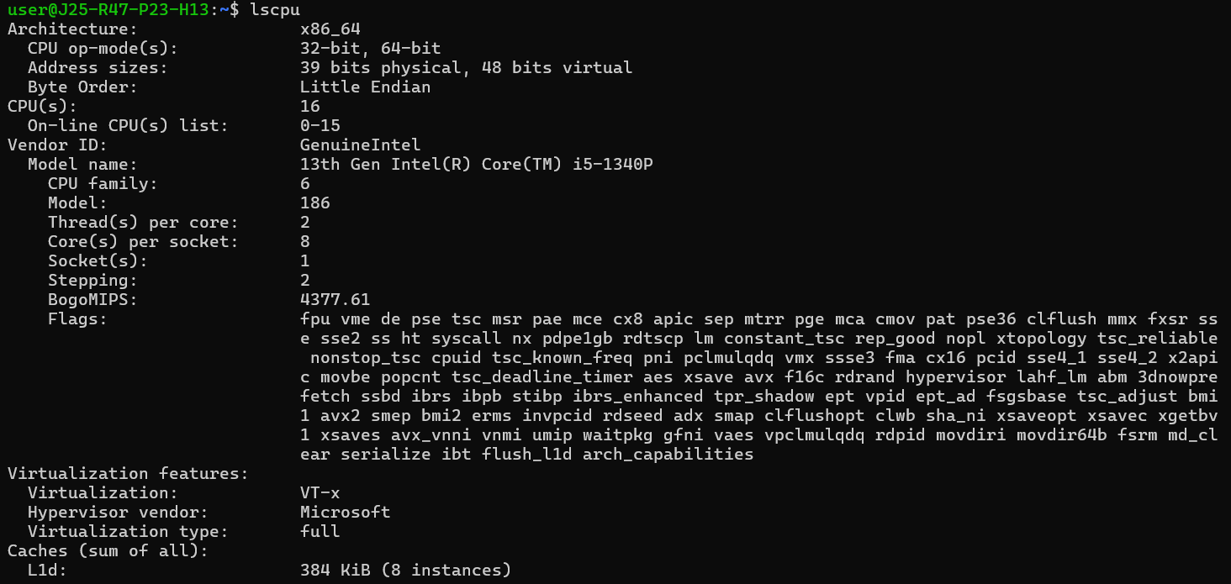
Displays CPU architecture, number of cores, threads, and processor details.
7. Check filesystem UUIDs
sudo blkid
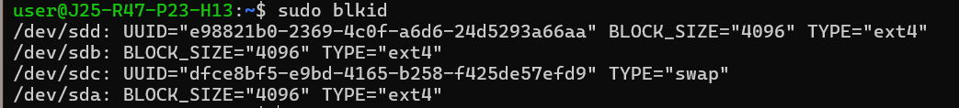
Displays block device information, including filesystem types and UUIDs. Useful when configuring disk mounts.
8. Check environment variables
printenv JAVA_HOME
Displays the JAVA_HOME environment variable. Useful when troubleshooting Java and Maven configuration.
9. Extract a filename from a path
basename /var/log/jenkins/jenkins.log
Outputs jenkins.log. Useful in shell scripts when you need only the filename from a full path.
10. Check system uptime and load
Uptime
Displays how long the Linux system has been running, the number of logged-in users, and system load averages. Useful for monitoring server health.

